ESTIMATION OF BUSINESS EXPENSES

1.INTRODUCTION
- This provides details on the overall pictures of the proposed business expenses.
- Project report is a written document relating to any investment of a business
- The project has been apparaised and found feasible
- Its consists of information on economic , technical , financial , managerial and production aspects.
- It enables the entrepreneur to know the inputs and helps him to obtain loans from banks or financial institutions.
1.1 OVERVIEW
- Write Down your Revenue and sales. first, decide on the time period you are measuring.
- Write Down All of your Expenses . Again , accounting software will do this for you.
1.2 PURPOSE
- Estimation are documents that provide approximate costs for a project .
- Small businesses create them for potential clients so both parties are clear on the ins and outs of a project before it starts.
- Fresh books has an estimates feature that help you build an estimate quickly and easily.
2. PROBLEM DEFING& DESIGN THINKING
4 COMMON CHALLENGES AND PLTFALLS IN DESIGN THINKING
- Lack of in-depth user research . Design thinking is human- centered .
- A company culture that doesn't foster collaboration .
- Inability to adjust to a non-linear process .
- Not letting go of a bad ideas.
- Dive head first into design thinking.
2.1 EMPATHY MAP
2.2 BRAIN STORMING MAP
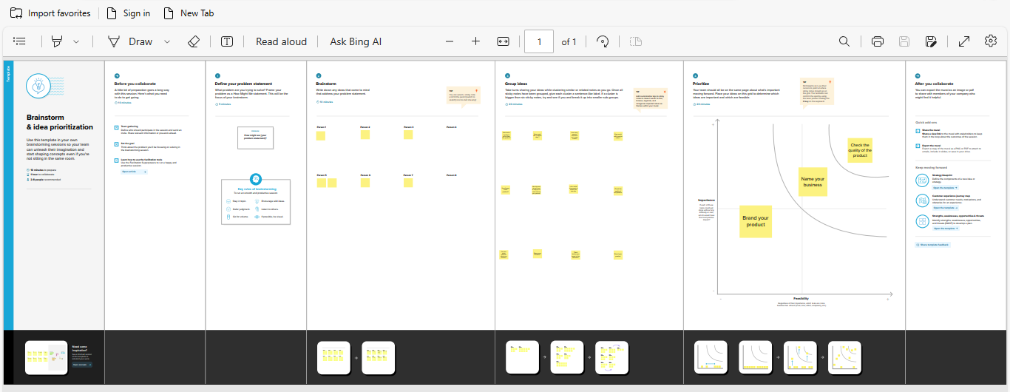

3.RESULTS

BREAKDOWN

4.ADVANTAGES AND DISADVANTAGES
4.1 ADVANTAGES
- Cost of goods sold for ordinary business operations.
- Wages , salaries , commissions , other labor (i.e. per piece contracts)
- Utilities (i.e. heat , A/C , lighting , water , telephone ).
- Rent .
- Repairs and maintenance
- Insurance rates.
- Payable interest.
- Bank charges/fees.

4.2 DISADVANTAGES
- Time commitments.
- Dealing with stress.
- Risk of failures.
- High competition.
- Possible lack of guidance.
- Lack of business processes and operational procedures.
5. APPLICATION
5.1 EXPENSES: INSIGHTS INTO DIVERSE BUSINESS COSTS
- Annual pay roll.
- Expenses of YOY.
- Maintenance of buildings cost.
- Transportation.
- Tax and license cost.
- Contract labor cost.
- Fuel cost.
- Advertising and promoting.
- Equipment amount.
- Electricity amount.
- Employees (contribution and pension)
6.CONCLUSION
1. In conclusion, cost estimation is an important component of project management of project management that ensures projects are finished on schedule and within budgets.
2. Since inaccurate cost estimating is crucial for all stakeholders engaged in a projects.

7.FUTURE COPE
1.The process of forecasting the financial and other resources needed to complete a project within a defined scope.
2.Cost estimation accounts for each element required for the projects- from materials to labor –and calculates a total amount that determine a project’s budget

